Weifeng Lai (NUID: 001561798)

**Program Structures & Algorithms**

**Fall 2021**

**Assignment No. 2**

**Part1**

Unit test screenshots:

1. TimerTest

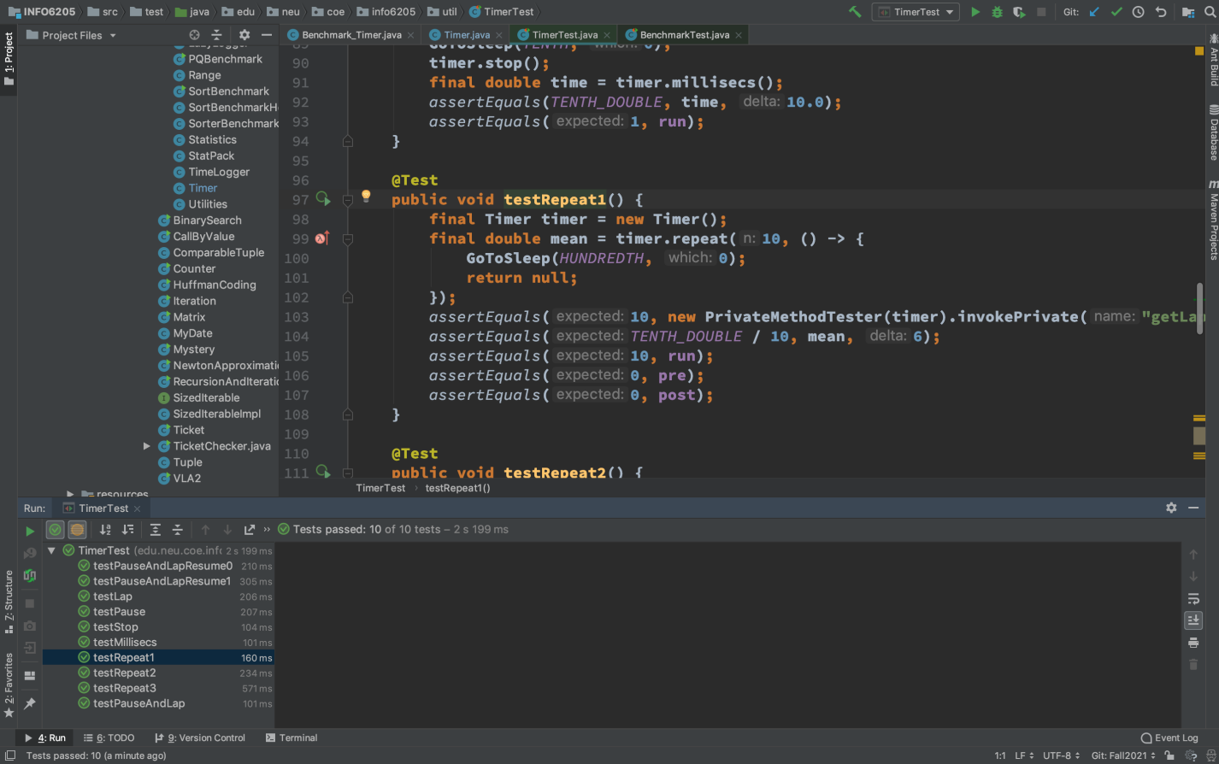

1. BenchmarkTest

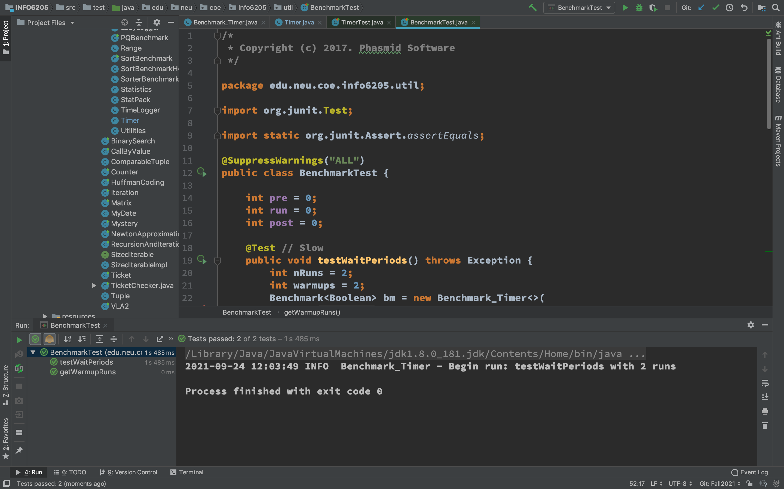

**Part2**

Unit test screenshot of InsertionSortTest:

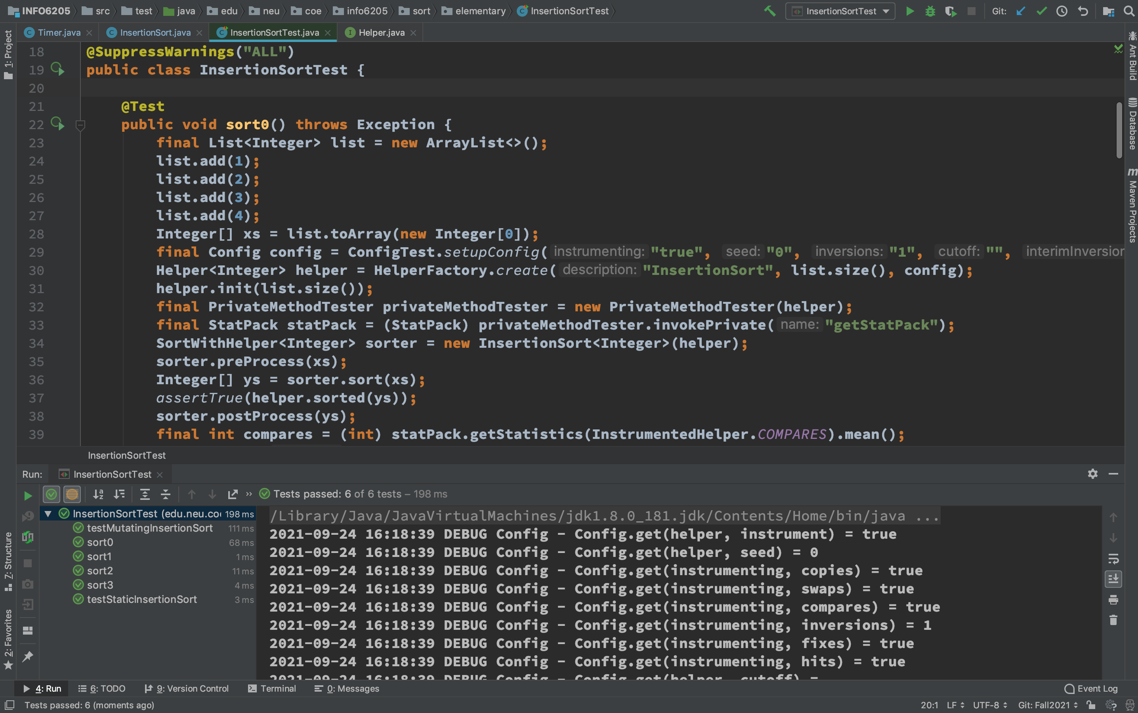

**Part3**

Screenshot my own unit test which aims at measuring the running times of insertion sort algorithm implemented in part2 four different initial array ordering situations: random, ordered, partially-ordered and reverse-ordered.

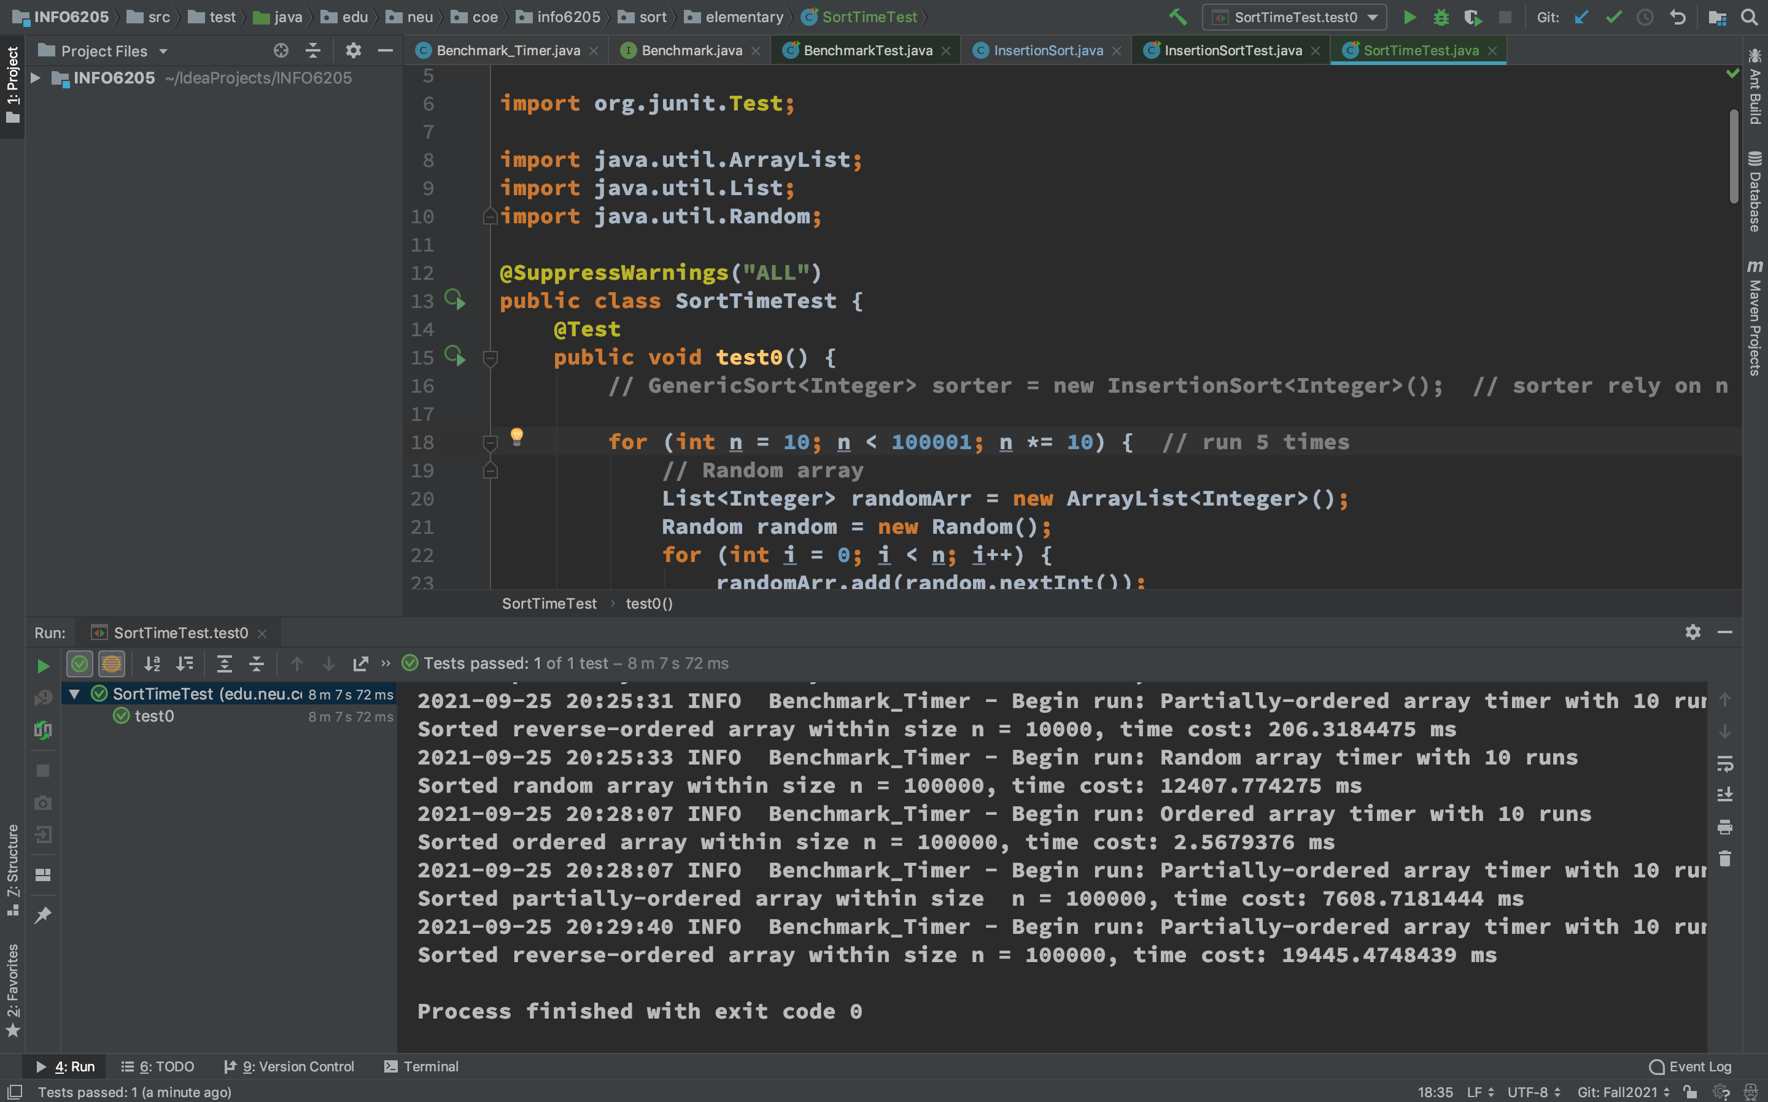

I drew a table which records cost time for sorting arrays with 4 different ordering situation and different n as following:

|  |  |  |  |  |
| --- | --- | --- | --- | --- |
| **n** | **Random** | **ordered** | **partially-ordered** | **Reverse-ordered** |
| **10** | 0.025 ms | 0.004 ms | 0.009 ms | 0.009 ms |
| **100** | 0.208 ms | 0.006 ms | 0.093 ms | 0.128 ms |
| **1000** | 2.900 ms | 0.011 ms | 1.357 ms | 2.303 ms |
| **10000** | 129.255 ms | 0.185 ms | 78.120 ms | 206.318 ms |
| **100000** | 12407.774 ms | 2.567 ms | 7608.718 ms | 19445.475 ms |

From this test result picture, we can sort these four kinds of arrays according to how much time is spent: Reverse-ordered > Random > Partially-ordered > Ordered.